Front-end (UI) App documentation and Unit test cases

for

Telia assignment

V1.0

Author: Likhitha Pentakota

**CATS Public API**

**CAT Public API References to fetch the breeds**

* **Host**: api.thecatapi.com
* **Protocols**: https
* **Responds With**: application/json
* **Endpoints used**: “/breeds” - To fetch list of cat breeds

**Scope:** Create React App for front-end starter with CATS public breeds API and implement following features to App

1. Display all the fetched cat breeds
2. Allow searching on the front-end (at least by name and breed group)
3. Allow sorting on the front-end
4. Implement appropriate loader, state handler and Pagination

**Solution:** This App was implemented based on CATS public API breeds data and React and Node js are used to implement the App with all the requested below features.

1. Display all the fetched cat breeds – Fetched all the breeds with CATS public api and displayed as grid with all cat breeds
2. Search on front-end – implemented search functionality to search breed by using any string from all breeds
3. Allow sort data on front-end – Sort on front-end is implemented with pagination. Sort works with toggle (Ascending or Descending) operation to sort the data displayed on each page.
4. Implement appropriate loader, state handler and Pagination -
   1. Loader: Loader is implemented when the fetched data is loading to display on front-end
   2. State handler: React Hooks useState and useEffect have used.
   3. Pagination: slice each data fetched by API with all cats to display data into multiple pages

**Unit testing:**

Case1: Fetched all the breeds using Cats public API and displayed breeds as cards on frontend.

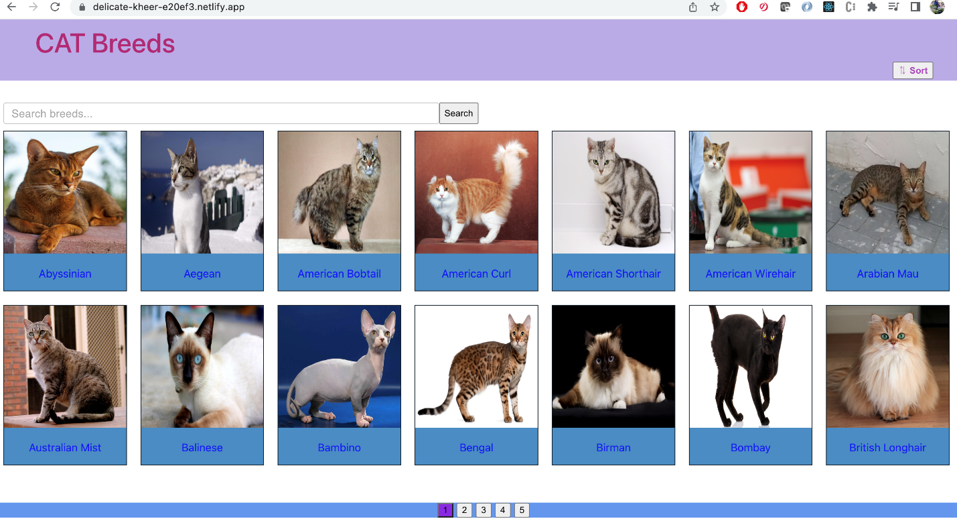

Case2: Allow Searching on frontend- Search was implemented with string operation and it allows user to search with 3 characters in any of the breed parameters.

Search with data where it doesn’t exist

Case3: Allow sorting in frontend

Before sort

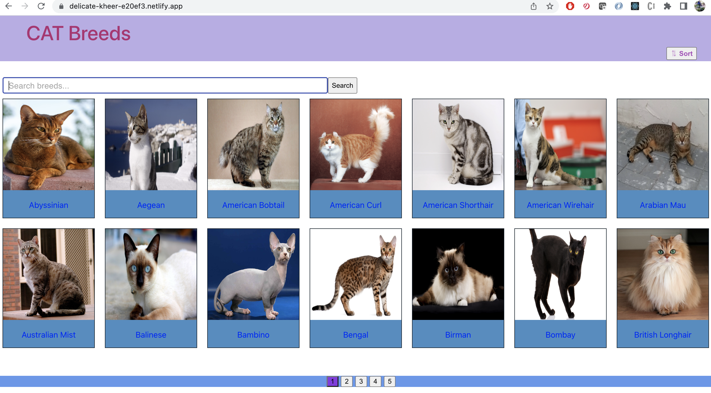

After click on sort, it will change to descending order

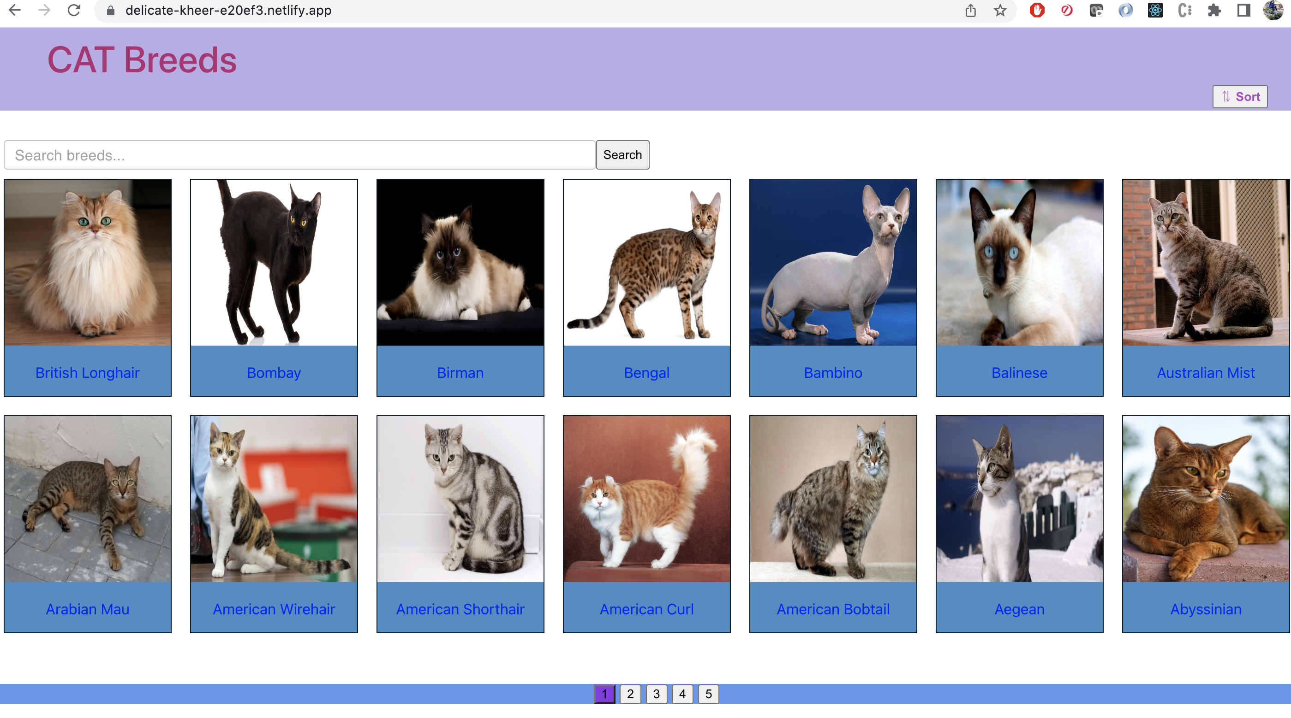

Again, when user click on sort it will toggle and sort in Ascending order

Case4: Loader and Pagination

Loading while loading data to display

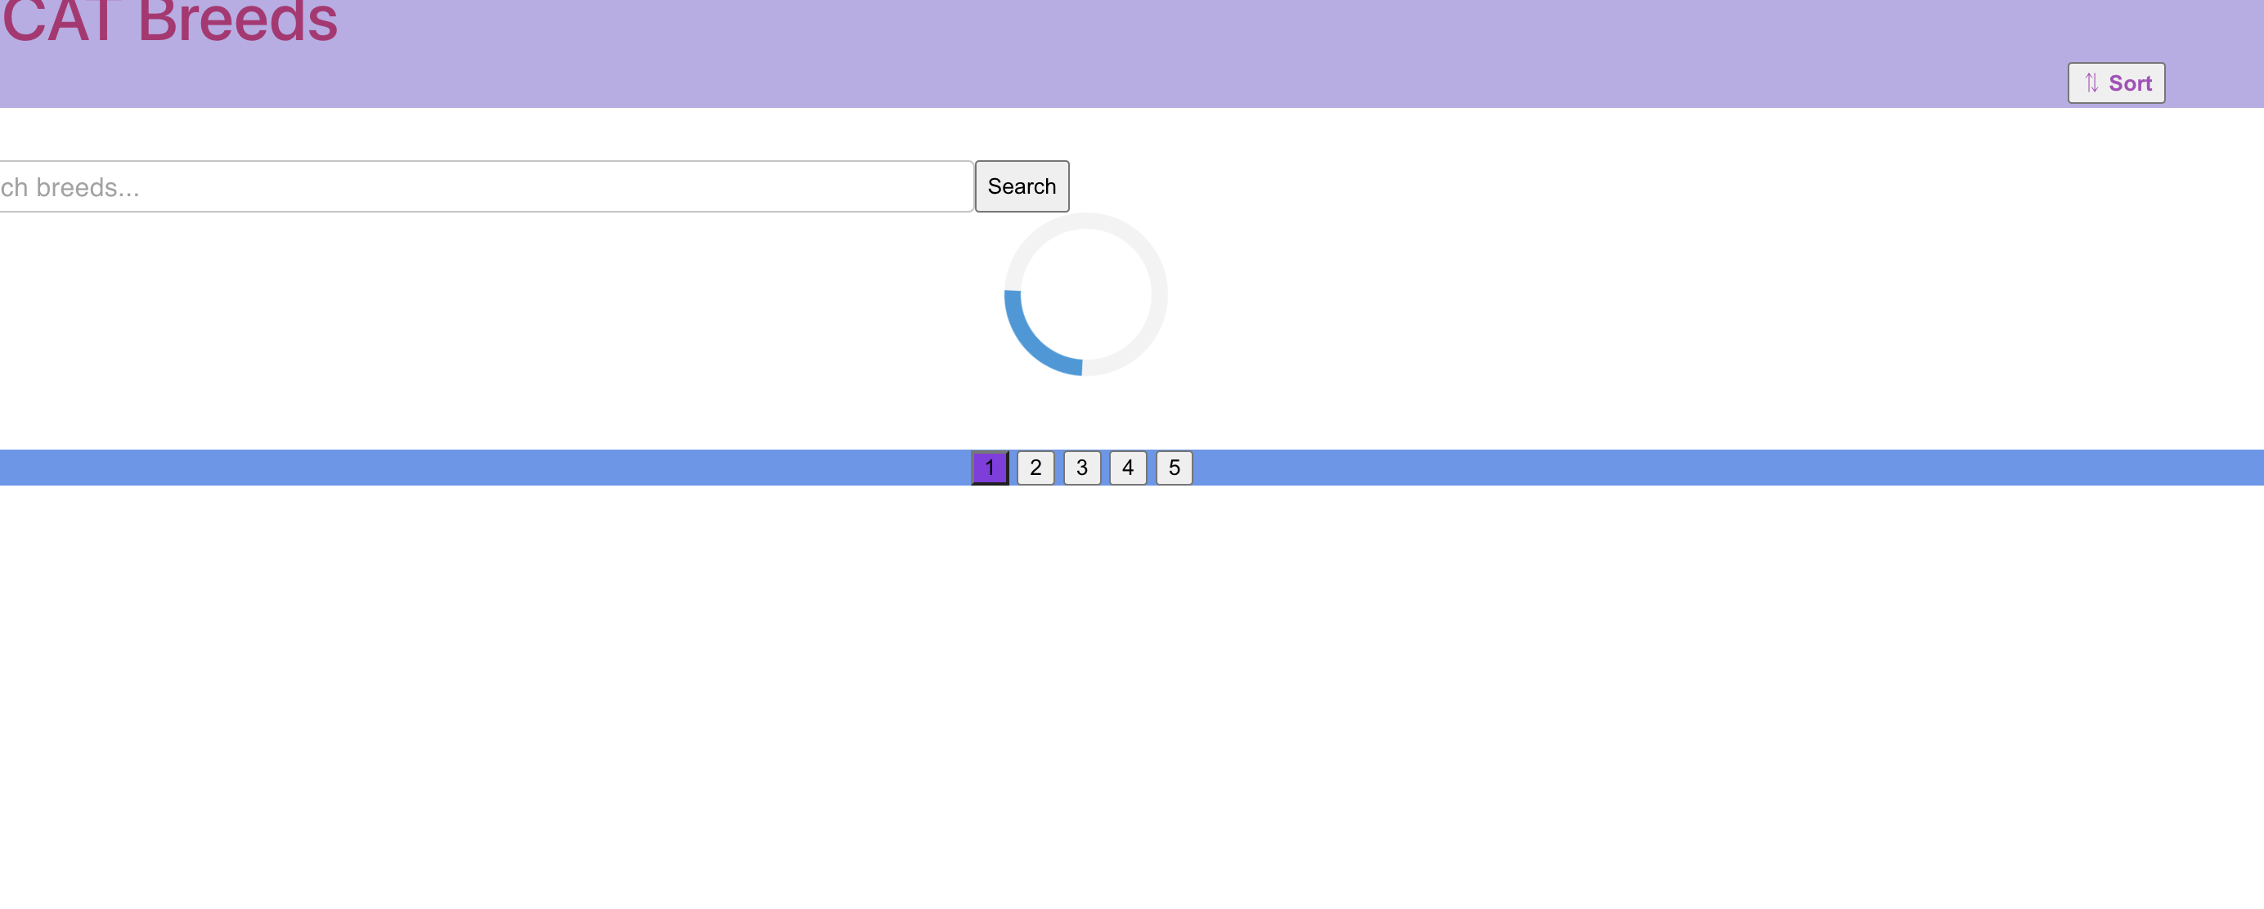

Pagination – Pagination will be displayed based on number of records and that are sliced per page. Current page is highlighted with purple.



**Conclusion**: It was really a good exercise to became strong myself in front-end application and I developed with all of my knowledge and experience in react and node js technologies and with possible best practices. I believe that the requested functionalities are implemented and the same was tested in unit testing.

**Learnings**:

1. Implementing Front-end APP with new functionalities
2. Experience in testing UI features